
enquiries@baththeatrical.com Tel: (01373) 472786
Regency measurement form
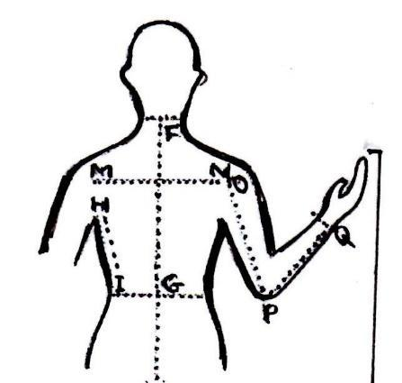
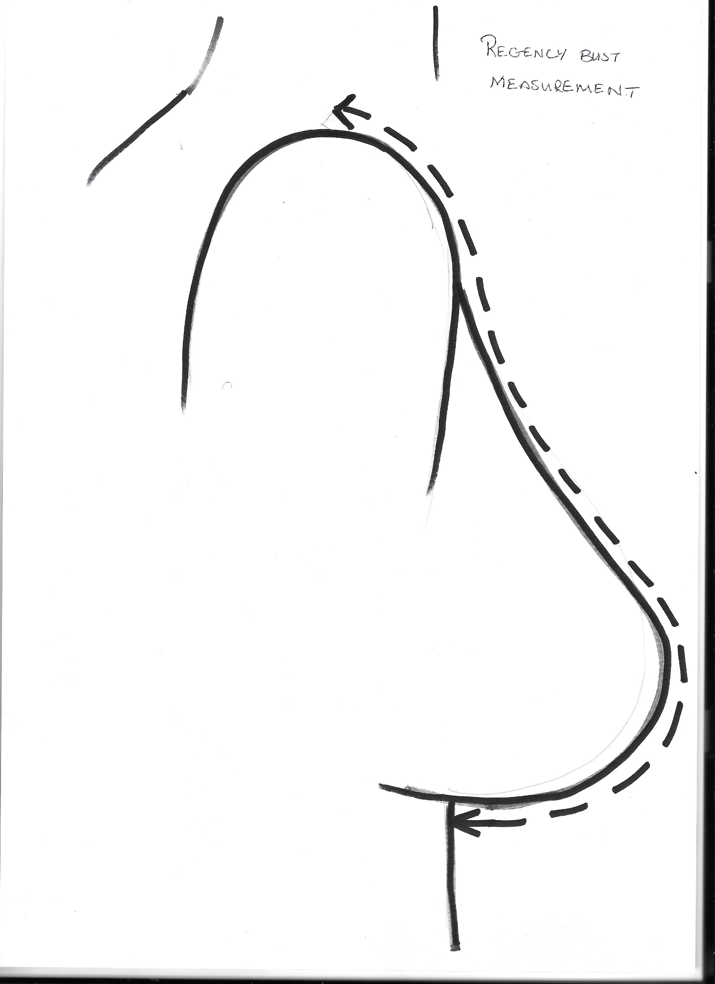
Please ensure each numbered column is used for individual party members
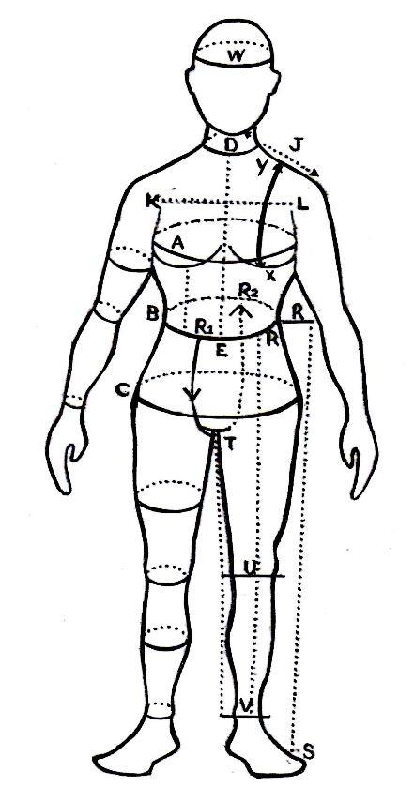
Please complete in INCHES and refer to above pictures for measurement guide.
Name  Please indicate whether male or female | 1 | 2 | 3 | 4 | 5 | 6 | 7 | 8 | 9 | 10
Height
A chest/bust
Under bust (ladies only)
Y – X Mid shoulder
to under bust (ladies only)
B waist
(tummy waist!)
Under bust to ground (ladies only)
C hips
M-N across back
F - G nape to waist (gents)
O-Q outer arm to wrist
Around arm (bicep)
T-U-V inside leg
Around calf
Head circumference
Collar
Hair colour

